Feng Chia University

Electrical Engineering Fundamentals II Lab

Laboratory 5

AC RLC Circuits and Phasor

Instructor: Prof. Shyan-Lung Lin

Student Name: 周嘉禾

Student ID: D1166506

Experiment Date:28/03/2024

1. Introduction
2. To observe the RLC Circuits and Phasor under Alternative Current
3. Materials
   1. Waveform Generator
   2. Digital Oscilloscope
   3. Digital Multimeter
   4. Devices

Resistors: R = 1 Ω, 10 Ω, 100 Ω, 1kΩ

Capacitor: C = 0.1 μF, 0.01 μF

Inductor: L = 1 mH

1. Circuit diagram

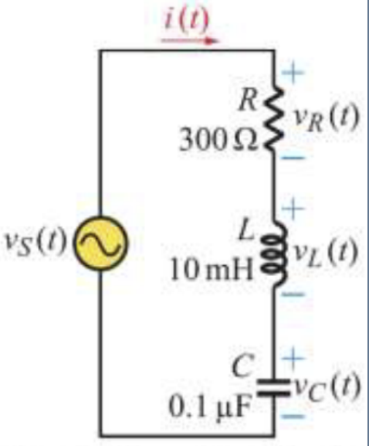

▲ Figure 1. Circuit of Experiment 5.a RLC Series Circuit

▲ Figure 2. Circuit of Experiment 5.b RLC Parallel Circuit

1. Methods

Using Digital Multimeter to observe current and voltage and Oscilloscope to observe the wave.

1. Experiments data
   1. Experiment 5.a RLC Series Circuit

Table 1: Measurement of RLC Series Circuit

|  |  |  |  |  |
| --- | --- | --- | --- | --- |
|  | VS | VR | VL | VC |
| Theoretical | 2 V | 1.8639 V | 0.3568 V | 1.0819 V |
| Measurement | 1.7683 V | 1.5128 V | 0.3146 V | 0.9057 V |

|  |  |  |  |  |
| --- | --- | --- | --- | --- |
|  | I | XL | XC | Z |
| Theoretical | 6.2131 mA | 57.4283 Ω | 174.1301 Ω | 321.8995 Ω |
| Measurement | 4.7835 mA | 65.7657 Ω | 189.3279 Ω | 369.6666 Ω |

* 1. Experiment 5.b RLC Parallel Circuit

Table 3: Measurement of RLC Parallel Circuit

|  |  |  |  |  |  |
| --- | --- | --- | --- | --- | --- |
|  | VS | IR | IL | IC | I |
| Theoretical | 4 V | 4 mA | 57.87 mA | 2.7646 mA | 55.255 mA |
| Measurement | 2.8176 V | 2.7271 mA | 49.63 mA | 0.8661 mA | 48.674 mA |

|  |  |  |  |  |
| --- | --- | --- | --- | --- |
|  | BL | BC | Y | Z |
| Theoretical | 14.469 S | 0.691 S | 13.814 S | 72.3918 Ω |
| Measurement | 17.614 S | 0.307 S | 17.275 S | 57.8872 Ω |

1. Results

▲ Figure 3. Results of Experiment 5.b.2

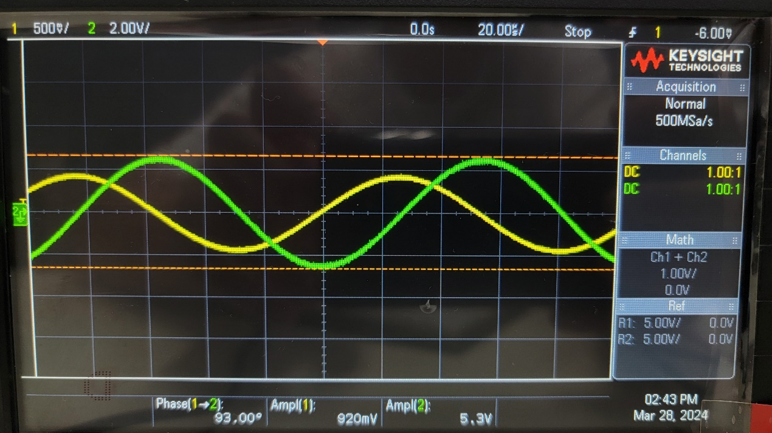

▲ Figure 4. Results of Experiment 5.b.3

▲ Figure 5. Results of Experiment 5.b.4

▲ Figure 6. Results of Experiment 5.c.2

▲ Figure 7. Results of Experiment 5.c.3

▲ Figure 8. Results of Experiment 5.c.4

1. Discussion

None

1. Conclusion

From the graphs and experimental datas above, voltage, current, and impedance behalf as the experiments before.